Score Analysis 作品導引

旋律  Melody | 以附點節奏為基礎，模進句為節奏發展模式。 | Based on dotted rhythms, the sequence of motifs is used as the rhythmic development pattern.
調式  Tonality | F 大調 | F major
曲式／織體  Form/ Texture | 以鋼琴伴奏的主調性合唱曲。  副歌／主歌／副歌／主歌／副歌 | Homophonic vocal piece with piano accompaniment.  Chorus / Verse / Chorus / Verse / Chorus
音域  Musical Range | C4 to D5
拍子  Meter | 4/4  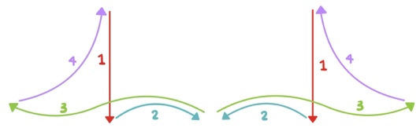
力度  Dynamics | 全曲力度漸大，隨着副歌重複，音量會逐漸推大。 | The entire piece gradually increases in dynamics, with the volume building progressively with each repetition of the chorus.

Junior Primary 初小 P1-P3

Warm up  5-10 mins  熱身  5-10分鐘 | 1.1 Happy face Sad face  Ask student to start with a neutral facial expression.  When you say "Big " everyone should make their eyes and mouths as large and wide as possible, holding this expression until you say out "Smal." where everyone should scrunch up their faces to make them look as small as possible.  To add more variety and fun, you can incorporate emotions and other expressions. For instance, try "Big Happy Face," "Small Angry Face," "Big Scary Face," or "Big Grateful Face." | - 面面不同  請學生先擺出一個中立的表情。  當你說「大」時，每個人應該把眼睛和嘴巴張得又大又寬，並保持這個表情直到你說「小」，這時每個人應該把臉皺起來，使它看起來儘可能小。為了增加更多的變化和樂趣，你可以加入情緒和其他表情。例如，試試「開心」、「生氣」、「恐怖」或「感恩」。 | PP 2
Core Teaching Activity I  10 mins  核心教學活動 I  10 分鐘 | 1.2 Don’t clap this one back  The teacher demonstrates different rhythms, each lasting no longer than four beats, using their hands, body, voice, and even the floor, while the children replicate the rhythms. However, if they hear the rhythmic pattern from Bar 1 in any form, they do not clap it back. The teacher then asks how many times this pattern appears in chorus 1 (the answer is four). Finally, the students learn to sing chorus 1 and the other verses. | 1.2 不要重複這個節奏  老師示範不同的節奏，每個節奏不超過四拍，使用手、身體、聲音，甚至是地板去演奏出這個節奏，學生們接著模仿這些節奏。然而，如果他們聽到任何形式的副歌第1小節的節奏模式，他們就不會回拍。然後，老師問這個節奏模式在第一段副歌中出現了幾次（答案是四次）。最後，學生們學習唱第一段副歌和其他的段落 | PP  3-5
Core Teaching Activity II  10 mins  核心教學活動 II  10 分鐘 | 1.3 Act it out  Ask the students (as a group / individually) to read the lyrics of verses. The teacher will distribute emotion cards so that students can read the lyrics expressing different emotions, such as angry, grateful, or sad. The other students will then vote to choose the best emotion which fits to the context of the song, with teachers’ guidance. | 1.3 聚光燈下朗讀歌詞  要求學生（作為一組/個別）閱讀歌詞。老師會分發情感卡片，讓學生以不同的情感，如憤怒、感激或悲傷，來詮釋歌詞。其他學生將投票選擇最適合歌曲背景的情感，並在老師的指導下進行 | PP 6
Extension activities  20 mins  延伸活動 20 分鐘 | 1.4 Let’s Draw  Ask students to draw their own unique person on paper. Remind students that this should not be somebody they know; this unique person should come from their imaginations. Remind them to think first about the features the persons head will have. They should include as much detail as possible in their drawings.  Putting them together –  Teacher’s message: Highlight the Everybody is different, or unique. What a person looks like on the outside has nothing to do with what is inside! God created us as individual unique person. Every person has special talents, special qualities...this is what makes us – a school, everyone matters, because that what makes our community. | 1.4 齊來畫一畫  老師的信息：強調每個人都是不同的，或者獨特的。一個人外表的樣子與內在無關！上帝創造了我們作為獨特的個體。每個人都有特殊的才能，特別的品質......這就是我們成為一所學校的原因，每個人都重要，才可形成我們的社區。  下一步，請學生在紙上畫出他們自己創造的人物。提醒學生這個人物不應該是他們認識的某個人；這個獨特的人物應該來自他們的想像。這個人包含所有學生覺得種要的性格和特徵。 | PP 7  WS 1
Extension activities  10 mins  延伸活動 10 分鐘 | Design and Write a Thank You Card: Ask students to thank teachers and others who have supported you on your learning journey. | 設計並寫下感謝卡：請學生感謝老師和其他在你學習旅程中支持過你的人。 | PP 12
Prayer Suggestion:  建議禱文： | Dear God, thank you for making each one of us different and unique. Help us remember that what a person looks like on the outside does not matter as much as what is inside. You created each of us with special talents and qualities. These differences make our school and community strong and special. Please help us appreciate and celebrate each other's uniqueness every day. Amen. | 親愛的天父，感謝您使我們每個人都不同和獨特。請幫助我們去緊記一個人外表的樣子並不像內在那樣重要。您為我們每個人賦予了特殊的才能和品質。這些不同使我們的學校和社區更加堅強和特別。求您幫助我們每天欣賞並感謝彼此的不一樣。阿門 | PP 8

Senior Primary 高小P4-6

Warm up  5-10 mins  熱身  5-10分鐘 | 2.1 Blowing out candles  Ask the students to picture a large birthday cake in front of them, adorned with four big candles. They will blow these out in four short bursts. Instruct them to take a deep breath in through the nose for a count of four, hold it for two counts, and then exhale through the mouth to extinguish the candles. Emphasize that they should aim not to take any extra breaths in between to help them practice breath control.  Continue the exercise by gradually increasing the number of candles until you reach eight. In the final round, take a deep breath in for a count of four, hold it for two, and then blow out all the candles in one steady breath over eight counts while making the ‘s’ sound. | 2.1 吹熄蠟燭  請學生們想像面前有一個大生日蛋糕，上面插著四根大蠟燭。他們需要用四次短促的吹氣來吹熄這些蠟燭。指導他們用鼻子深吸一口氣，數到四，然後憋氣數到二，再用嘴巴呼氣來吹熄蠟燭。強調他們在這過程中不要額外吸氣，這有助於練習呼吸控制。  繼續這個練習，逐漸增加蠟燭的數量，直到達到八根。在最後一輪中，用鼻子深吸一口氣，數到四，然後憋氣數到二，接著在八拍內用穩定的呼氣一次吹熄所有蠟燭，並發出「s」的聲音。 | PP 9
Core Teaching Activity I  10 mins  核心教學活動 I  10 分鐘 | 2.2 Breathe in/ Breathe out  Sing or play the song for the class, asking the students to follow the phrasing/ contour—either using the score or cues from the teacher—so they know when to breathe in and blow out their candles (from Bar 1 to Bar 24). Then, learn to sing Verse 1 and the other verses. | 2.2 吸氣 / 呼氣  老師演唱或播放這樂曲，要求學生跟隨樂曲的旋律線：可以使用樂譜或老師的提示，讓他們知道何時吸氣和吹熄他們的蠟燭（從第1小節到第24小節）。然後，學習唱第1段和其他的段落。 | PP 10
Core Teaching Activity II  10 mins  核心教學活動 II  10 分鐘 | 2.3 Dotted Dotty Improvisation  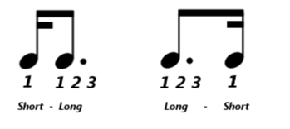  Learn this rhythm pattern by chanting "Short Long" and "Long Short." Integrate these two rhythmic beats to create a 4/4 meter body percussion pattern.  Use this pattern to accompany any familiar songs in 4/4 meter, such as school songs or hymns. As a class, listen to the song and have the students raise their hands whenever they hear the "long short short long" dotted pattern. Afterward, they can check the music and count how many times this pattern appears in each chorus (the answer is four times).  Suggested Warm-Up:  The teacher produces a sound—like clapping hands, snapping fingers, tapping knees, or stomping feet—and the students echo the sound. Once everyone is making the same sound, the teacher introduces a new one for the children to imitate. After experimenting with various sounds, one student can be selected to lead the activity. | 2.3 附點節奏即興練習  通過重覆朗讀「短 長」和「長 短」來學習這個節奏模式。將這兩個節奏拍子結合起來，創造出一個4/4拍的身體敲擊節奏。  使用這個節奏來伴奏任何熟悉的4/4拍節奏歌曲，如校歌或聖詩。接著聆聽要學習的樂曲，讓學生聆聽樂曲，請學生們聽到「長 短 短 長」的附點節奏模式時舉手。隨後，他們可以檢查樂譜，並指出每個合唱部分中這個節奏模式出現的次數（答案是四次）。  建議熱身活動：  老師發出聲音，如拍手或踏步，學生們重複這個聲音。一旦每個人發出相同的聲音，老師引入一個新的聲音讓學生們模仿。在嘗試了各種聲音後，可以選擇一名學生來帶領這個活動。 | PP 11
Extension activities  20 mins  延伸活動 20 分鐘 | 2.4 Simon Says  Instruct the students to pay close attention while playing the game, as each of them will need to share one new thing they learned about a classmate at the end. Start a game of Simon Says, giving prompts such as:  "Simon says, 'Everyone with long hair, stand up.'"  "Simon says, 'Everyone whose favourite food is sushi, balance on one foot.'"  "Simon says, 'Everyone who attends XXX school.'"  Choose categories that are suitable for your class..  After the game, have the students sit in a circle. Ask each student to share one similarity they discovered with another classmate during the game. The trait they mention must be something new to them. For example, a student might say, "I didn’t know that Anna has a dog." | 2.4 老師話  在遊戲中，指示學生要仔細注意，因為每個人都需要在結束時分享一件他們了解到的新事物。開始一場老師話的遊戲，給出提示如下：  "老師話，'所有長頭髮的人，站起來。'"  "老師話，'所有喜歡壽司的人，單腳站立。'"  "老師話，'所有在XXX學校的學生。'"  選擇適合你們班級的類別。遊戲結束後，讓學生們坐成一圈。請每位學生分享在遊戲中發現的與另一位同學的一個相似之處。他們提到的特點必須是對他們來說新的。例如，一位學生可能會說："我不知道心宜有一隻狗。"
Extension activities  10 mins  延伸活動 10 分鐘 | Design and Write a Thank You Card: Ask students to thank teachers and others who have supported you on your learning journey. | 設計並寫下感謝卡：請學生感謝老師和其他在你學習旅程中支持過你的人。 | PP 12  WS 2
Prayer Suggestion:  建議禱文： | Dear God, thank you for making each one of us different and unique. As we learned through playing Simon Says, we have both similarities and differences. Help us remember that what a person looks like on the outside doesn't matter as much as what is inside. You created each of us with special talents and qualities. These differences make our school and community strong and special. Please help us appreciate and celebrate each other's uniqueness every day. Amen. | 親愛的天父，感謝您使我們每個人都不同和獨特。通過玩老師話的遊戲，我們了解到我們既有相似之處，也有不同之處。請幫助我們去緊記一個人外表的樣子並不像內在那樣重要。您為我們每個人賦予了特殊的才能。這些不同使我們的學校和社區更加豐富和特別。求您幫助我們每天欣賞並感謝彼此的不一樣。阿門。 | PP 8

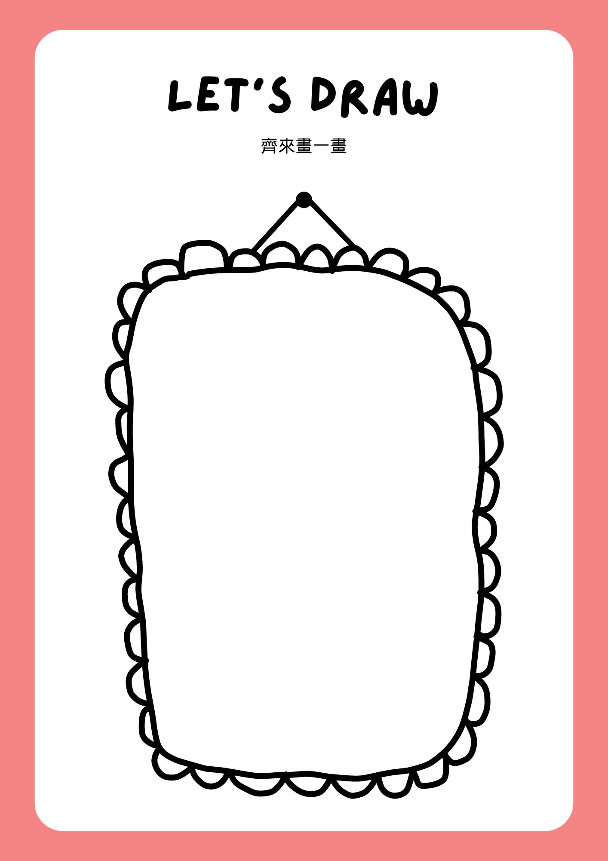
1.1


